**Birla Institute of Technology & Science, Pilani**

**Work-Integrated Learning Programmes Division**

**First Semester 2022-2023**

**Comprehensive Examination (EC-3 Make-up)**

Course No. : SE ZG685

Course Title : SOFTWARE PRODUCT MANAGEMENT

Nature of Exam : Open Book

Weightage : 40%

No. of Pages = 3

No. of Questions = 8

Duration : 2 Hours

Date of Exam : Saturday, 26/11/2022 (FN)

Note:

1. Please follow all the *Instructions to Candidates* given on the cover page of the answer book.
2. All parts of a question should be answered consecutively. Each answer should start from a fresh page.
3. Assumptions made if any, should be stated clearly at the beginning of your answer.
   1. Design 4 Customer interview Questions to assess the value of the product described in the case study “FastTag”. [4]

Ans:

How is compare to other product

Chatgpt ans

**How has the FastTag product improved your experience with toll payments? Can you provide specific examples of how it has made the process more convenient or efficient for you?**

This question helps to gauge the overall impact of FastTag on the customer's experience with toll payments. It encourages the customer to provide specific instances where the product has brought value by streamlining the payment process.

**Prior to using FastTag, what challenges or frustrations did you encounter with traditional toll payment methods? How has FastTag addressed or resolved these challenges for you?**

This question aims to uncover the pain points and difficulties customers faced before adopting FastTag. It allows them to compare their previous experiences with the benefits and solutions provided by FastTag, highlighting the value the product brings in addressing those challenges.

**Have you noticed any cost savings or time savings since using FastTag? Can you estimate the impact it has had on your expenses or travel time?**

This question explores the financial and time-related benefits customers have experienced with FastTag. It helps assess the value in terms of tangible outcomes, such as reduced costs or saved time, which are essential factors for customers in evaluating a product's worth.

**How does FastTag compare to other toll payment options you have used or considered? What unique features or advantages does FastTag offer in comparison?**

This question seeks to understand how FastTag differentiates itself from other competing solutions in the market. By comparing FastTag to alternative options, customers can express their perceptions of the product's unique features, advantages, or value propositions that set it apart from the competition.

* 1. Design 4 Customer interview Questions to assess the value of the software product described in the case study “DBS home loan”. [4]

Ans: Here are four customer interview questions to assess the value of the software product described in the case study "DBS home loan":

1. **How has the DBS home loan software improved your experience in managing your home loan application and approval process?**

* This question aims to understand the specific benefits and value that customers perceive when using the DBS home loan software. It helps assess whether the software delivers on its promises of convenience, efficiency, and a streamlined application process.

1. **Can you share any instances where the DBS home loan software has helped you save time or simplify complex tasks during the loan application process?**

* This question explores the impact of the software on customers' time-saving and simplification of tasks. It focuses on the value of avoiding manual paperwork, reducing administrative burdens, and enhancing overall efficiency.

1. **In what ways has the DBS home loan software provided transparency and clarity in terms of understanding your loan options, interest rates, and repayment terms?**

* This question seeks to understand how the software has improved transparency and clarity for customers. It helps assess the value of providing comprehensive information about loan options, interest rates, and repayment terms, ensuring customers can make informed decisions.

1. **Have you experienced any financial benefits or cost savings as a result of using the DBS home loan software? If yes, could you provide some examples?**

* This question aims to uncover any financial advantages that customers have experienced with the DBS home loan software. It helps assess the software's value proposition in terms of potential savings on interest rates, reduced fees, or improved financial management capabilities.

Remember, these questions should be customized based on the specific details and objectives of the DBS home loan case study.

* 1. Design 4 Customer interview Questions to assess the value of the software product described in the case study “Acko car insurance”. [4]

**Ans:** Here are four customer interview questions to assess the value of the software product described in the case study "Acko car insurance":

1. **How has the Acko car insurance app improved your experience in purchasing and managing your car insurance policy?**

* This question aims to understand the specific benefits and value that customers perceive when using the Acko car insurance app. It helps assess whether the app delivers on its promises of convenience, ease of use, and a simplified insurance buying and management process.

1. **Can you share any instances where the Acko car insurance app has helped you save time or simplify complex tasks during the insurance purchase or claim settlement process?**

* This question explores the impact of the app on customers' time-saving and simplification of tasks. It focuses on the value of avoiding lengthy paperwork, reducing administrative burdens, and enhancing overall efficiency during claim settlement.

1. **In what ways has the Acko car insurance app provided transparency and clarity in terms of understanding your insurance coverage, premium amounts, and claim settlement process?**

* This question seeks to understand how the app has improved transparency and clarity for customers. It helps assess the value of providing comprehensive information about coverage, premiums, and claims processes, ensuring customers can make informed decisions.

1. **Have you experienced any financial benefits or cost savings as a result of using the Acko car insurance app? If yes, could you provide some examples?**

* This question aims to uncover any financial advantages that customers have experienced with the Acko car insurance app. It helps assess the app's value proposition in terms of potential savings on premiums, discounts, or improved claim settlement processes.

Remember, these questions should be customized based on the specific details and objectives of the Acko car insurance case study.

* 1. Analyze product market fit of “Toothsi dental aligner app”. Create the lean canvas board. [4 + 4 = 8]

Ans:

Market fit of Toothsi dental aligner app

* Target customer – (Market)
* Under serve needs – (Market)
* Value proposition – (Product)
* Feature set – (Product)
* UX– (Product)

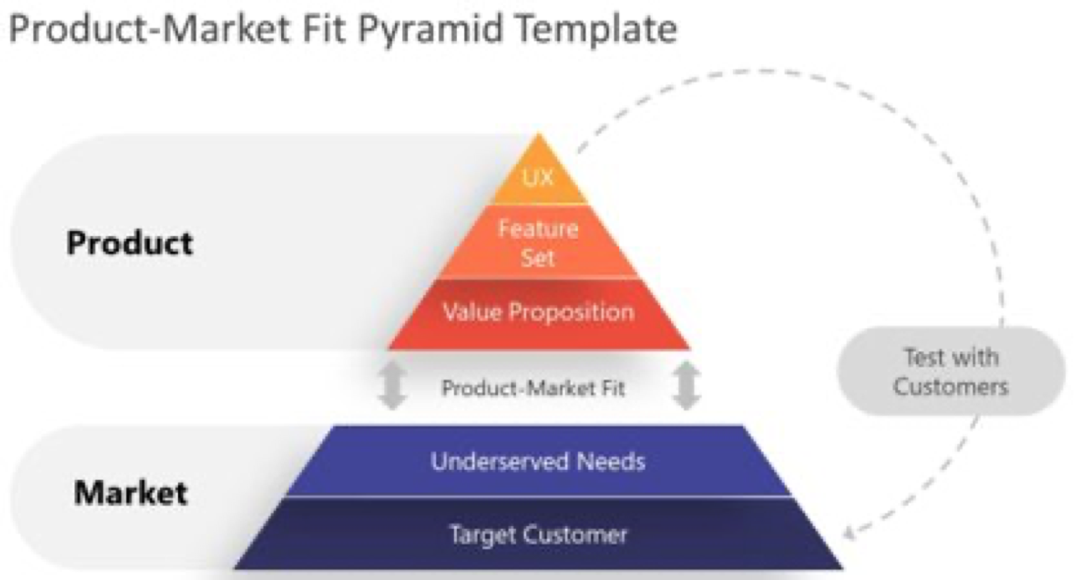

Similar like this



**ChatGPT Answer:**

To analyze the product-market fit of the "Toothsi dental aligner app" and create a Lean Canvas, we need to consider various aspects of the product and its target market. The Lean Canvas is a concise framework that captures the essential elements of a business model. Let's break it down:

**1.Problem:**

* Misaligned teeth are a common dental issue that affects people's self-confidence and oral health.
* Traditional braces can be expensive, inconvenient, and aesthetically unappealing.

**2.Solution:**

* The Toothsi dental aligner app offers an alternative solution to traditional braces by providing clear aligners that gradually straighten teeth.
* The app leverages technology to streamline the teeth alignment process, allowing users to track progress and communicate with dental professionals remotely.

**3.Key Metrics:**

* Number of users utilizing the app for teeth alignment.
* Customer satisfaction ratings and reviews.
* Revenue generated through aligner sales and additional services.

**4.Unique Value Proposition:**

* Convenient and affordable teeth alignment through clear aligners.
* Seamless integration of technology and dental expertise for an enhanced user experience.
* Personalized treatment plans and remote monitoring for effective results.

**5.Channels:**

* Mobile app stores (Apple App Store, Google Play Store) for app distribution.
* Online marketing campaigns targeting individuals seeking teeth alignment solutions.
* Partnerships with dental clinics for referrals and aligner fittings.

**6.Customer Segments:**

* Teenagers and adults seeking teeth alignment without the hassle of traditional braces.
* Individuals looking for a convenient and discreet dental treatment option.
* Tech-savvy users comfortable with using mobile apps for healthcare purposes.

**7.Cost Structure:**

* App development and maintenance costs.
* Dental professionals' salaries for remote monitoring and treatment plan adjustments.
* Manufacturing and supply chain costs for aligner production.

**8. Revenue Streams:**

* Sales of dental aligner kits and related accessories.
* Subscription fees for premium features within the app.
* Potential partnerships with dental insurance providers.

**9.Key Activities:**

* App development and updates to enhance user experience.
* Collaborating with dental professionals to ensure effective treatment plans and monitoring.
* Marketing and customer acquisition strategies.

**Key Partnerships:**

* Dental professionals and orthodontists for treatment plan creation and remote monitoring.
* Dental clinics for aligner fittings and referrals.
* Potential collaborations with dental insurance companies.

**Customer Relationships:**

* Regular communication and support channels between users and dental professionals.
* In-app chat or video consultation options.
* Providing educational content and tips for users' oral health.

Based on this analysis, Toothsi dental aligner app appears to have a strong product-market fit. The app addresses a common problem with an innovative solution, leveraging technology and convenience. However, the success of the app will depend on effective marketing, partnerships with dental professionals, and ensuring a positive user experience throughout the teeth alignment process.

* 1. Analyze product market fit of “Redbus bus booking app”. Create the lean canvas board. [4 + 4 = 8]

Ans: To analyze the product-market fit of the "Redbus bus booking app" and create a lean canvas board, we need to consider various aspects of the product and its target market. Here's a breakdown of the different components of the lean canvas board for Redbus:

**Problem:**

* Difficulty in finding and booking bus tickets, especially for long-distance travel.
* Limited availability of reliable information regarding bus routes, schedules, fares, and seat availability.
* Limited access to real-time updates on bus availability and seat availability.

**Solution:**

* The Redbus app enables users to search for bus routes, view available seats, and book tickets online.
* Users can access real-time information about bus operators, timings, and prices.
* The app provides secure payment options and e-tickets for easy ticket management.
* It offers a comprehensive database of bus routes, schedules, fares, and seat availability from various bus operators.

**Unique Value Proposition:**

* Redbus provides an easy-to-use mobile app for searching, comparing, and booking bus tickets.
* It offers a wide range of bus operators, routes, and real-time seat availability information.
* Redbus ensures a seamless and reliable booking experience for its users.

**Key Metrics:**

* Number of app downloads and active users.
* Conversion rates from search to bookings.
* Customer reviews and ratings.
* Revenue generated through ticket sales and commissions.

**Customer Segments:**

* Commuters and travelers who rely on buses as a mode of transportation.
* Individuals seeking a convenient and hassle-free way to book bus tickets.

**Channels:**

* Mobile app stores for user acquisition and downloads.
* Digital marketing campaigns targeting relevant audiences.
* Partnerships with bus operators to expand the reach and availability of tickets.

**Revenue Streams:**

* Revenue is generated through a commission on each ticket sold through the Redbus platform.
* Additional revenue can be generated through advertising partnerships or premium booking features.

**Cost Structure:**

* Costs include app development and maintenance
* Marketing and advertising expenses, customer support, and partnerships with bus operators.
* Commission or transaction fees from bus operators.

**Key Metrics:**

* Number of app downloads and active users.
* Conversion rates from search to ticket bookings.
* Customer satisfaction ratings and reviews.
* Repeat booking rates and customer retention.

**Unfair Advantage:**

* Redbus's extensive network of bus operators and partnerships.
* Strong brand reputation and customer trust.
* Advanced technology for real-time seat availability and booking management.

**Revenue Streams:**

* Commission or transaction fees from bus ticket bookings.
* Potential partnerships with hotels, tour operators, or travel insurance companies for additional revenue streams.

**Key Partnerships:**

* Bus operators for listing their services and ensuring availability of accurate information.
* Travel agencies or tour operators for potential cross-promotion or package deals.
* Potential collaborations with hotels, airlines, or other travel-related services.

The lean canvas board provides a concise overview of the product-market fit for the Redbus bus booking app. It outlines the problem being solved, the target market, the unique value proposition, the solution provided, and key aspects related to revenue, costs, metrics, and advantages.

* 1. Analyze product market fit of “RazorPay payment gateway app”. Create the lean canvas board. [4 + 4 = 8]

**Ans:** To analyze the product-market fit of the "RazorPay payment gateway app" and create a lean canvas board, we need to consider various aspects of the product and its target market. Here's a breakdown of the different components of the lean canvas board for RazorPay:

**Problem:**

* Businesses and individuals face challenges in accepting online payments securely and efficiently.
* Limited availability of reliable and user-friendly payment gateway solutions.

**Solution:**

* The RazorPay app provides businesses and individuals with a user-friendly platform to accept online payments.
* Users can integrate RazorPay's payment gateway into their websites or mobile apps.
* The app offers features such as payment links, subscription billing, and invoice generation.

**Unique Value Proposition:**

* RazorPay offers a secure, easy-to-integrate payment gateway solution.
* It provides a wide range of payment options, including credit/debit cards, net banking, UPI, and digital wallets.
* RazorPay ensures fast settlements, comprehensive reporting, and seamless checkout experiences.

**Customer Segments:**

* Businesses of all sizes that require a payment gateway for their online transactions.
* Individuals and freelancers who need a convenient way to receive payments.

**Channels:**

* Digital marketing campaigns targeting businesses and individuals in need of a payment gateway.
* Partnerships with e-commerce platforms, website builders, and software providers for integrations.

**Cost Structure:**

* App development and maintenance costs.
* Infrastructure and server costs for managing payment transactions.
* Customer support and operational expenses.

**Revenue Streams:**

* Revenue is generated through transaction fees, typically a percentage of the payment amount processed through RazorPay.
* Potential partnerships or white-labeling services for additional revenue streams.

**Key Activities:**

* App development and updates to enhance security and user experience.
* Integration with new platforms, systems, and payment methods.
* Building and maintaining partnerships with e-commerce platforms and software providers.

**Key Partnerships:**

* E-commerce platforms for seamless integration and cross-promotion.
* Software providers and developers for integration support and expanded functionality.
* Potential collaborations with banks, digital wallets, or other financial institutions.

**Customer Relationships:**

* Seamless onboarding process and integration support for businesses.
* Dedicated customer support channels for assistance with technical issues or payment-related queries.
* Regular communication and updates regarding new features or changes to the payment gateway.

Q.3Set(A) Discuss Positioning and Messaging for Twilio product. [4]

**Ans:**

**Positioning:** Twilio's positioning should emphasize its key differentiators and unique selling points (USPs). Here are some potential positioning statements for Twilio:

* Twilio is the cloud communication platform that enables developers and businesses to quickly and easily build and scale real-time communication applications across multiple channels.
* Twilio provides powerful APIs and flexible SDKs that enable businesses to integrate messaging, voice, and video communication capabilities into their applications with ease.
* Twilio empowers businesses of all sizes to create meaningful customer experiences by enabling real-time communication on any channel, at any scale.

**Messaging:** To support its positioning, Twilio's messaging should focus on the benefits and outcomes that customers can achieve by using the platform. Here are some potential messaging themes for Twilio:

* Empowering businesses to create engaging customer experiences through real-time communication
* Enabling developers to build and scale communication applications quickly and easily
* Providing a reliable, secure, and flexible communication platform that can integrate with any application
* Offering a comprehensive suite of communication APIs and tools to meet the needs of businesses across industries

Q.3Set(B) Discuss Positioning and Messaging for Tally product. [4]

**Ans:**

Positioning and messaging are crucial components of a successful marketing strategy for any product, including Tally software. Tally is a popular business accounting software widely used by small and medium-sized businesses to manage their financial operations. Here are some key points to consider when discussing positioning and messaging for Tally:

**Positioning:**

* **Identify the target audience:** The first step in creating a positioning strategy for Tally is to identify the target audience. In this case, the target audience would be small and medium-sized businesses.
* **Determine the unique selling proposition:** Tally software offers a comprehensive accounting and financial management solution for businesses. The unique selling proposition for Tally could be its ability to simplify accounting processes, reduce errors, and save time and money for businesses.
* **Focus on benefits:** When positioning Tally, it's essential to focus on the benefits that the software provides. This could include improved financial management, increased accuracy, and better insights into business operations.
* **Highlight competitive advantages:** Tally has several competitors in the accounting software market. To differentiate itself, Tally can highlight its competitive advantages, such as its ease of use, affordability, and scalability.

**Messaging:**

* **Keep it simple:** The messaging for Tally should be simple and easy to understand. It should clearly communicate the benefits of the software and how it can help businesses manage their finances more effectively.
* **Focus on the target audience:** The messaging should be tailored to the needs of the target audience. This could include highlighting specific features that are particularly relevant to small and medium-sized businesses.
* **Highlight success stories:** Tally can use success stories of businesses that have used the software to showcase its effectiveness. This could include testimonials or case studies that demonstrate how Tally has helped businesses improve their financial management.
* **Address pain points:** Tally can also address common pain points that businesses face when it comes to accounting and financial management. This could include issues such as managing cash flow, tracking expenses, and preparing financial statements.

In summary, positioning and messaging are critical components of a successful marketing strategy for Tally software. By identifying the target audience, highlighting the unique selling proposition and benefits, and tailoring the messaging to the needs of the target audience, Tally can effectively differentiate itself from its competitors and showcase its effectiveness in helping businesses manage their finances.

Q.3Set(C) Discuss Positioning and Messaging for AirBnB product. [4]

**Ans:**

Positioning and messaging are critical aspects of any product or brand, including Airbnb. Let's delve into how Airbnb positions itself and the key messages it conveys:

**Positioning:**

* **Unique Accommodation Experience:** Airbnb positions itself as a platform that offers unique and personalized accommodation experiences. It emphasizes the concept of staying in someone's home or a distinctive property, enabling travelers to immerse themselves in the local culture and community.
* **Accessible Travel:** Airbnb positions itself as an inclusive platform that provides a wide range of accommodations suitable for various budgets and travel preferences. It aims to make travel accessible to everyone by offering options beyond traditional hotels and resorts.
* **Trust and Safety:** Airbnb emphasizes its commitment to trust and safety. It has implemented various measures, such as host and guest verification, secure payment systems, and review systems, to foster trust and ensure a safe experience for users.
* **Community and Connection:** Airbnb positions itself as a community-driven platform that fosters connections between hosts and guests. It promotes the idea of sharing spaces, stories, and experiences, encouraging travelers to connect with local hosts and fellow travelers.

**Messaging:**

* **"Live like a local":** Airbnb's messaging highlights the opportunity for travelers to live like a local, immersing themselves in the culture and lifestyle of the destination they are visiting. It emphasizes the authenticity and unique experiences that can be gained by staying in an Airbnb accommodation.
* **"Choose from a variety of homes":** Airbnb's messaging emphasizes the extensive range of accommodation options available to cater to diverse traveler needs and preferences. Whether it's a cozy apartment, a rustic cottage, or a luxurious villa, Airbnb encourages users to find the perfect space for their travel experience.
* **"Feel at home anywhere":** Airbnb's messaging conveys the idea of feeling at home anywhere in the world. It aims to create a sense of comfort and belonging by providing accommodations that offer the comforts and amenities of a home, no matter the destination.
* **"Connect with hosts and fellow travelers":** Airbnb's messaging highlights the community aspect of the platform. It encourages travelers to connect with hosts, who can provide local insights and recommendations, and with fellow travelers, fostering a sense of camaraderie and shared experiences.
* **"Travel with confidence":** Airbnb's messaging emphasizes its commitment to trust and safety. It reassures travelers that they can book accommodations with confidence, knowing that Airbnb has implemented robust safety measures and verification processes to ensure a secure experience.

Overall, Airbnb's positioning and messaging revolve around the concepts of unique experiences, accessibility, trust, community, and connection. By focusing on these key elements, Airbnb has successfully established itself as a leading platform for alternative accommodations and immersive travel experiences.

1. “Prove your product first, scale / optimize later” is a best practice for startups. How was this done in case of ID Fresh foods? [4]

**Ans:** ID Fresh Foods is a successful Indian startup that followed the best practice of "Prove your product first, scale/optimize later**." The company began its journey with a focus on product quality and customer satisfaction before scaling up its operations. Here's how ID Fresh Foods implemented this approach:**

1. **Focus on Product Quality:** ID Fresh Foods prioritized the quality of their products from the very beginning. They ensured that their food items were made with fresh ingredients, hygienically processed, and free from preservatives. This commitment to quality helped them gain customer trust and loyalty.
2. **Localized operations:** Instead of trying to reach a wide audience from the start, ID Fresh Foods initially focused on serving the local market. They started with a single city (Bengaluru) and expanded gradually to other cities, ensuring that they were able to maintain product quality, customer satisfaction, and operational efficiency.
3. **Word-of-mouth marketing:** ID Fresh Foods relied heavily on word-of-mouth marketing to generate awareness and build a customer base. By consistently delivering high-quality products, they earned positive reviews and recommendations from customers, which helped them gain traction and establish a strong reputation.
4. **Continuous improvement:** While scaling their operations, ID Fresh Foods continued to invest in research and development to improve their products and processes. They actively sought customer feedback, incorporated suggestions, and fine-tuned their recipes and production methods. This dedication to continuous improvement allowed them to maintain product quality while scaling their operations.
5. **Scalability and optimization:** Once ID Fresh Foods had established a strong foundation and proven their product in the market, they focused on scaling up and optimizing their operations. They implemented advanced technology, automated processes, and expanded their production facilities to meet growing demand without compromising on quality.
6. **Direct Customer Interaction:** ID Fresh Foods focused on direct customer interaction to gather feedback, understand preferences, and refine their products. They actively engaged with customers through various channels, including in-person interactions, customer surveys, and social media platforms. This direct feedback loop helped them iterate on their products and continuously improve.
7. **Establishing Strong Supply Chain and Infrastructure:** ID Fresh Foods invested in building a robust supply chain and infrastructure to support their operations. They ensured the sourcing of high-quality ingredients, implemented rigorous quality control processes, and set up state-of-the-art manufacturing facilities. This emphasis on infrastructure laid the foundation for scaling up operations later
8. “Prove your product first, scale / optimize later” is a best practice for startups. How was this done in case of Spotify? [4]

**Ans:**

Spotify, the popular music streaming platform, also exemplifies the best practice of "Prove your product first, scale/ optimize later." **Here's how Spotify implemented this approach:**

1. **Product Development and Innovation:** Spotify focused on developing a robust and user-friendly music streaming platform with a vast library of songs. They prioritized creating an exceptional user experience, offering features like personalized playlists, discovery algorithms, and seamless cross-platform integration.
2. **Market Testing and Feedback:** Spotify initially launched in a limited number of markets, primarily targeting European countries. This allowed them to gather feedback from early adopters and iterate on their product based on user preferences and market demands.
3. **Refinement and Iteration:** Based on user feedback and data analytics, Spotify continuously refined and iterated on its platform. They introduced new features and improvements to enhance the user experience, such as social sharing, collaborative playlists, and personalized recommendations.
4. **Expansion to New Markets:** After proving the viability of their product and gaining a substantial user base in their initial markets, Spotify gradually expanded its operations to new regions, including the United States and other countries worldwide. This gradual expansion approach allowed them to learn and adapt to different markets' dynamics while continuing to optimize their platform.
5. **Licensing and Partnerships:** Spotify strategically negotiated licensing agreements with major record labels and artists, ensuring a comprehensive music library for its users. These partnerships played a crucial role in proving the value of the platform by offering a wide range of music content to attract and retain users.
6. **Scaling and Infrastructure Investment:** Once Spotify established its product-market fit and gained significant traction, they focused on scaling their operations and investing in infrastructure. This involved building data centers, optimizing server capacity, and improving streaming quality to handle the increasing user base and demand.
7. **Monetization and Revenue Streams: Initially**, Spotify relied on a freemium model, offering both free and premium subscription options. However, as they proved the value and popularity of their product, they gradually optimized their revenue streams by encouraging more users to upgrade to paid subscriptions and leveraging advertising as an additional source of revenue.
8. **Continuous Innovation and Differentiation:** Spotify continues to prioritize innovation and differentiation to stay ahead in the competitive music streaming industry. They have expanded their offerings beyond music, including podcasts and exclusive content collaborations with artists. These strategic moves help them diversify their product and maintain their position as a market leader.

By following the "Prove your product first, scale/ optimize later" approach, Spotify successfully established itself as one of the leading music streaming platforms globally. They focused on refining their product, expanding gradually, forming strategic partnerships, and continuously innovating to meet user needs and preferences. This approach allowed Spotify to build a strong brand and grow their user base, leading to their current position as a dominant player in the music streaming industry.

1. “Prove your product first, scale / optimize later” is a best practice for startups. How was this done in case of Netflix? [4]

**Ans:**

Netflix, the renowned streaming service, also followed the best practice of "Prove your product first, scale/ optimize later" in its journey. Here's how Netflix implemented this approach:

1. **Product Concept and Validation:** Netflix started as a DVD-by-mail rental service. They focused on providing a convenient and hassle-free way for customers to rent movies without the need to visit physical stores. By offering a vast DVD library and a subscription-based model, they proved the concept of convenient movie rentals and gained initial traction.
2. **Technological Innovation:** Netflix recognized the potential of streaming technology early on and invested in developing a streaming platform. They introduced the "Watch Instantly" feature, allowing customers to stream movies and TV shows directly on their computers. This innovation laid the foundation for their transition from a DVD rental service to a leading streaming platform.
3. **Market Testing and Iteration:** Netflix initially launched its streaming service as a complimentary feature for existing DVD subscribers. This approach allowed them to gather feedback, iterate on their streaming technology, and understand user behavior and preferences in the streaming space.
4. **Original Content and Differentiation:** As Netflix proved the value of its streaming service, it began producing original content, such as the critically acclaimed series "House of Cards" and "Stranger Things." By investing in original programming, Netflix aimed to differentiate itself from traditional TV networks and attract and retain subscribers.
5. **Expansion and International Markets:** Once Netflix established a strong foothold in the United States, they gradually expanded their streaming service to international markets. This approach allowed them to adapt their content offerings and marketing strategies to diverse regions while ensuring a strong product-market fit in each market.
6. **Data-driven Approach and Personalization:** Netflix heavily relies on data analytics and algorithms to personalize the user experience. They leverage user behavior, viewing history, and preferences to provide tailored recommendations and optimize content discovery, thereby enhancing user engagement and satisfaction.
7. **Investment in Infrastructure and Scaling:** As Netflix's subscriber base grew, they made significant investments in building a robust content delivery infrastructure and optimizing streaming quality. This included expanding server capacity, implementing content delivery networks (CDNs), and partnering with internet service providers (ISPs) for better streaming performance.
8. **Global Expansion and Localization:** Netflix continued its global expansion strategy by entering new markets worldwide. They emphasized localization efforts by providing region-specific content, language options, and localized marketing campaigns to cater to diverse cultures and preferences.
9. **Continuous Innovation and Adaptation:** Netflix has consistently focused on innovation and adapting to changing market dynamics. They introduced new features like offline downloads, interactive content, and adaptive streaming quality to enhance the user experience and stay ahead in the streaming industry.

By proving their product through the DVD rental service, validating the streaming concept, investing in original content, and continuously innovating, Netflix successfully demonstrated the "Prove your product first, scale/ optimize later" best practice. This approach allowed them to transition from a DVD rental company to a global streaming giant, revolutionizing the way people consume entertainment and positioning themselves as a leader in the streaming industry.

1. Which funding sources are suited for new startups. Justify [4]

**Ans:**

New startups have various funding sources available to them, depending on their specific needs and circumstances. Here are some funding sources commonly suited for new startups, along with their justifications:

* **Self-Funding or Bootstrapping:** Many startups begin by self-funding their ventures using personal savings, credit cards, or borrowing from friends and family. This approach allows founders to maintain control and ownership of their business while retaining flexibility in decision-making. It also demonstrates the founders' commitment and belief in their venture, which can attract external investors later on.
* **Friends and Family:** Seeking investment from friends and family can be an option when personal funds are limited. These individuals are often more willing to invest in the early stages of a startup and may be motivated by personal relationships and belief in the founder's abilities. However, it's essential to approach these investments professionally and ensure clear communication about risks and expectations.
* **Angel Investors:** Angel investors are high-net-worth individuals who provide capital and mentorship to startups in exchange for equity. They often have industry expertise and can provide valuable guidance and connections. Angel investors are more willing to take risks compared to traditional venture capitalists, making them a suitable funding source for early-stage startups.
* **Grants and Government Programs:** Startups can explore grants and government programs specifically designed to support entrepreneurship and innovation. These sources often have specific criteria, such as industry focus or social impact, but can provide non-dilutive funding and resources to support startup growth.

It's important for startups to consider their funding needs, growth plans, and alignment with specific funding sources before making a decision. Combining different funding sources or a staged approach may be appropriate, allowing startups to prove their concept, reach key milestones, and attract larger investments as they demonstrate progress and potential for scalability.

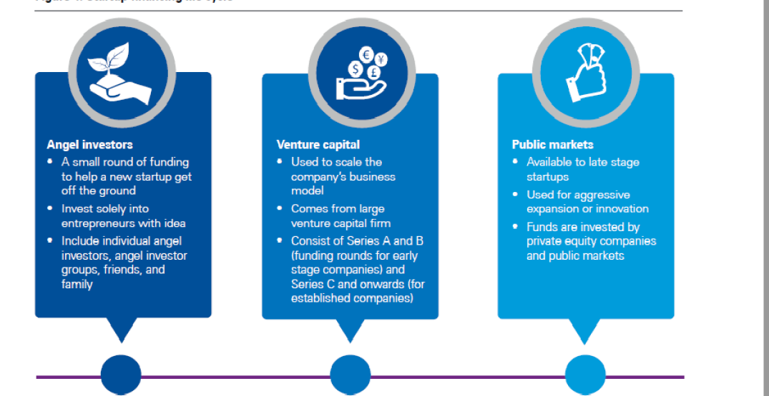

1. Which funding sources are suited for established and stable company. Justify [4]

Ans:

* Venture capital:
* **Venture Debt:** Venture debt is a form of debt financing specifically designed for later-stage startups and established companies with a strong growth trajectory. It provides additional capital alongside equity funding and can be used for working capital, equipment purchases, or strategic initiatives. Venture debt offers flexible repayment terms and may include warrants or equity kickers, allowing investors to participate in the company's success.
* **Bank Loans:** Established companies with a stable financial track record and strong collateral can secure bank loans. These loans provide capital for various purposes, such as expanding operations, acquiring assets, or funding working capital. Banks typically offer competitive interest rates and structured repayment terms, making them a suitable funding source for companies with predictable cash flows.
* **Debt Financing:** Established companies can also consider debt financing options such as corporate bonds or private placements. These sources allow companies to raise funds by issuing debt securities to institutional investors or the public. Debt financing provides a fixed-income stream for investors and can be an attractive option for companies with a solid credit rating and a track record of consistent performance.
* **Private Equity:** Established companies may seek funding from private equity firms. Private equity investors provide capital in exchange for equity ownership, often targeting companies with proven business models, steady cash flows, and growth potential. Private equity investments can support expansion plans, management buyouts, or liquidity events for existing shareholders.
* **Strategic Partnerships or Alliances:** Established companies can explore strategic partnerships or alliances with other companies in their industry or related sectors. These partnerships may involve investment, joint ventures, or revenue-sharing agreements. Strategic partnerships can provide access to capital, resources, expertise, and market opportunities, fostering growth and expanding the company's reach.

Each funding source has its own advantages and considerations, and the suitability depends on the company's specific situation, growth plans, and risk tolerance. Established and stable companies often have more options available to them compared to startups, allowing them to choose funding sources that align with their long-term objectives and financial position.

1. Which funding sources are suited for socially responsible company. Justify [4]

**Ans:**

**Crowd funding:** Crowdfunding platforms dedicated to social or environmental causes can be an effective way for socially responsible companies to raise funds. These platforms allow individuals or communities to contribute small amounts of money to support projects that align with their values. Crowdfunding for impact enables companies to engage a wider audience and generate support from like-minded individuals who believe in their mission.

**Social Venture Capital:** Social venture capital firms are dedicated to investing in businesses that have a clear social or environmental impact mission. These firms focus on funding companies that aim to address social issues or create positive change. Social venture capital provides not only financial support but also guidance, expertise, and access to networks that are essential for socially responsible companies.

By leveraging these funding sources, socially responsible companies can secure capital that aligns with their mission and values. These funding options not only provide financial support but also validate the company's commitment to social or environmental impact, attracting like-minded investors and stakeholders who are passionate about making a positive difference.

1. Which revenue model would you recommend for ‘Google Drive’ for corporates? Justify. [4]

**Ans:**

1. **Subscription Base model:** A subscription-based model allows Google Drive to generate a consistent and predictable stream of revenue from corporate customers. With a recurring payment structure, Google Drive can forecast its revenue and plan its resources accordingly. This provides stability and financial predictability, which is particularly important when catering to corporate clients.
2. **Value-added Features and Services:** With a subscription model, Google Drive can offer additional value-added features and services to corporate customers. This can include enhanced security and compliance features, advanced collaboration tools, priority customer support, and integration with other productivity applications. These value-added services can differentiate Google Drive from free or basic cloud storage offerings and justify the subscription cost.
3. **Data and Usage Insights:** A subscription-based model enables Google Drive to gather valuable data and usage insights about corporate customers. This data can be used to improve the service, identify trends, and develop new features that align with the specific needs of corporate users. The data-driven approach helps Google Drive stay competitive and deliver a more targeted and valuable solution to its corporate customers.

**Overall, the subscription-based revenue model is recommended for Google** **Drive targeting** corporates due to its scalability, predictability, value-added features, upselling opportunities, customer retention benefits, and the ability to gather valuable data and insights. This model allows Google Drive to generate a consistent revenue stream while continuously improving its offering to meet the evolving needs of corporate users.

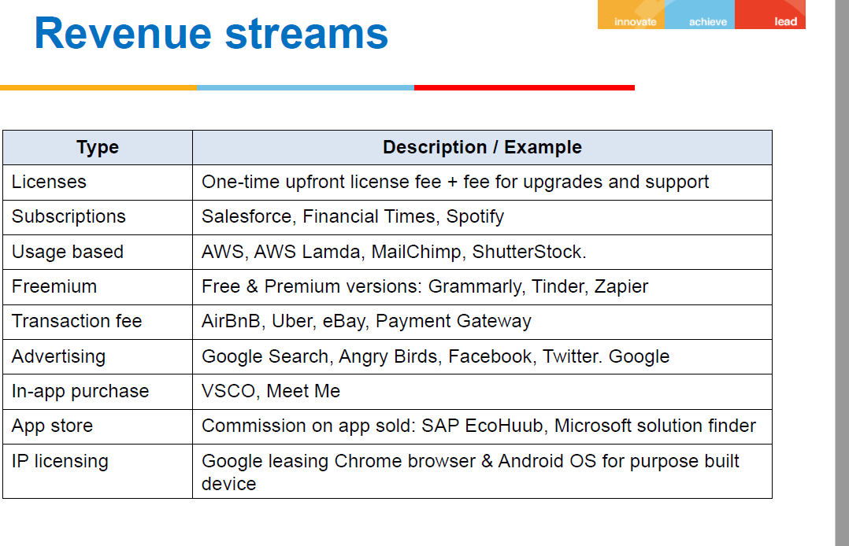

1. Which revenue model would you recommend for ‘Postman API testing’ product? Justify. [4]

Ans:

**Subscription-based revenue:** Overall, the SaaS subscription model is recommended for Postman API testing product due to its recurring revenue potential, scalability, value-based pricing, continuous product updates, customer relationships and retention, integration possibilities, and access to valuable data and insights. This model aligns with the software nature of the product, allowing Postman to deliver ongoing value to customers while sustaining a profitable business.

1. **Which revenue model would you recommend for ‘Kissflow” for corporates? Justify.** [4]

**Ans:**

For "Kissflow" targeting corporates, a recommended **revenue model would be the SaaS (Software as a Service) subscription model.** Here's the justification for this choice:

1. **Recurring Revenue:** The SaaS subscription model offers a steady and recurring revenue stream for Kissflow. Corporate customers pay a monthly or annual subscription fee to access the software platform and its features. This ensures a predictable cash flow for the company, allowing for better financial planning and investment in product development and support.
2. **Scalability:** The SaaS model allows Kissflow to scale its services to meet the needs of different-sized corporate customers. It can cater to small businesses, mid-sized enterprises, and large organizations. As the customer base grows, Kissflow can easily scale its infrastructure and resources to handle the increasing demand, ensuring a seamless user experience.
3. **Customizable Pricing:** With the SaaS model, Kissflow can offer flexible pricing options and plans tailored to the specific requirements of corporate customers. Pricing can be based on factors such as the number of users, workflow complexity, integrations, and additional features. This allows corporate customers to choose the plan that aligns with their budget and needs, ensuring they pay for the value they receive.
4. **Continuous Updates and Support:** As a SaaS provider, Kissflow can deliver regular updates and improvements to its platform. Corporate customers benefit from new features, bug fixes, security updates, and performance enhancements without the need for manual installations or updates. The SaaS model also enables Kissflow to provide ongoing customer support and assistance, ensuring high customer satisfaction and retention.
5. **Integration Capabilities:** Kissflow can leverage the SaaS model to integrate with other corporate systems and tools. This allows seamless data flow and collaboration within the organization's existing software ecosystem. Integration capabilities enhance the value proposition of Kissflow for corporates, as it becomes a central platform that can streamline and automate various business processes.
6. **Data Security and Compliance:** Kissflow can prioritize data security and compliance measures for its corporate customers. By implementing robust security protocols, encryption, and access controls, Kissflow can provide a secure environment for corporate data and ensure compliance with industry regulations. This helps build trust with corporates that handle sensitive information and have strict data protection requirements.
7. **Analytics and Reporting:** The SaaS model enables Kissflow to gather valuable data and provide analytics and reporting capabilities to corporate customers. The platform can generate insights and visualizations that help corporates monitor and analyze their workflows, identify bottlenecks, and make data-driven decisions for process optimization and improvement. These analytics features enhance the value of Kissflow for corporates and provide them with actionable insights.

Overall, the SaaS subscription model is recommended for Kissflow targeting corporates due to its recurring revenue potential, scalability, customizable pricing, continuous updates and support, integration capabilities, data security and compliance features, and analytics offerings. This model aligns well with the nature of the product, allowing Kissflow to deliver ongoing value and drive efficiency in corporate workflows while maintaining a sustainable revenue stream.

1. 2 friends got together to launch as B2B product company. In the first year they assessed the product idea, built an MVP to validate the idea, put together a team to build the product.

In the second year they started selling the product to a few companies and in the third year they increased their sales to even more customers.

In the first year the company did not make any profit. In the second year they made a small profit and in the third year they made even more profit. At the end of the third year their reached **the break-even point**.

Based on the description given above, explain how the company claims to have made profit in year 2 while the break-even was reached only at end of year 3. [4]

**Ans:**

The company claims to have made a profit in year 2 because the term "profit" in this context refers to the positive difference between revenue and expenses for that specific year. Although they made a small profit in year 2, it does not mean they reached the break-even point. The break-even point is the point at which total revenue equals total expenses, resulting in zero profit or loss.

Cost Allocation: The company might have allocated a portion of the initial development costs or overhead expenses to future years, which could reduce the expenses reported in the second and third years. By allocating costs over a longer period, the company can distribute the expenses and show a profit in the second year even though the break-even point was reached only at the end of the third year.

The company claims to have made a profit in year 2 because the term "profit" in this context refers to the positive difference between revenue and expenses for that specific year. Although they made a small profit in year 2, it does not mean they reached the break-even point. The break-even point is the point at which total revenue equals total expenses, resulting in zero profit or loss.

In the second year, the company may have generated enough revenue from selling the product to cover a portion of their expenses, resulting in a positive net income or profit for that year. However, their total accumulated expenses from the previous years, including the initial investment, development costs, and operational expenses, may still outweigh the cumulative revenue earned by the end of year 2.

The break-even point is reached at the end of year 3 when the cumulative revenue finally equals or exceeds the accumulated expenses of the company. It signifies the point at which the company starts covering all its costs and becomes financially self-sustainable.

So, while the company made a profit in year 2, it does not necessarily mean they were profitable overall or had reached the break-even point. The break-even point indicates the milestone where the company's revenue catches up with its cumulative expenses, resulting in a balanced financial state.

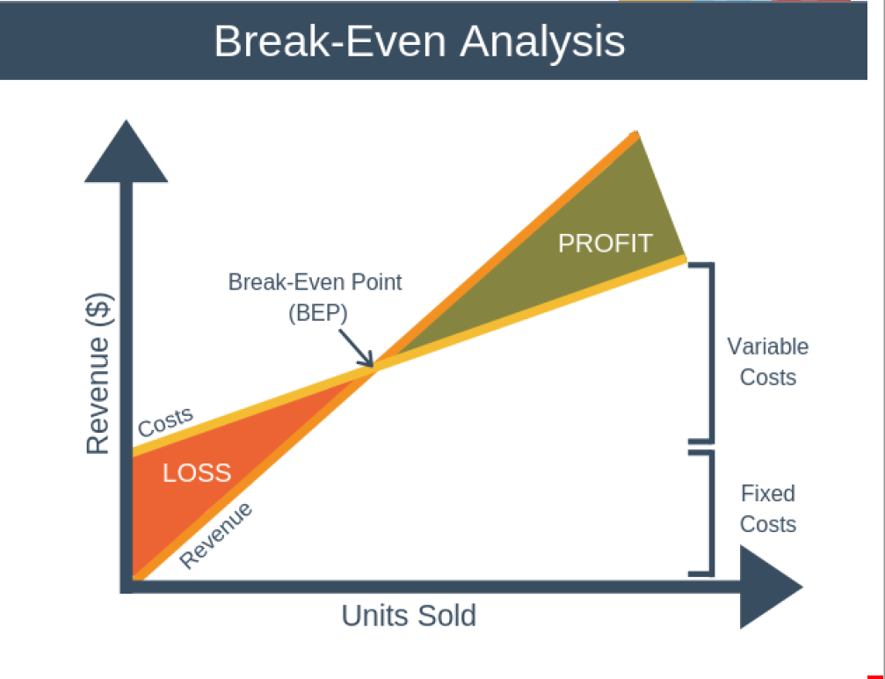

1. 2 friends got together to launch as B2B product company. In the first year they assessed the product idea, built an MVP to validate the idea, put together a team to build the product.

In the second year they started selling the product to a few companies and in the third year they increased their sales to even more customers.

In the first year the company did not make any profit. In the second year they made a small profit and in the third year they made even more profit. At the end of the third year their reached the break-even point.

Based on the description given above, explain how the company claims to have made profit in year 2 while the break-even was reached only at end of year 3. [4]

1. 2 friends got together to launch as B2B product company. In the first year they assessed the product idea, built an MVP to validate the idea, put together a team to build the product.

In the second year they started selling the product to a few companies and in the third year they increased their sales to even more customers.

In the first year the company did not make any profit. In the second year they made a small profit and in the third year they made even more profit. At the end of the third year their reached the break-even point.

Based on the description given above, explain how the company claims to have made profit in year 2 while the break-even was reached only at end of year 3. [4]



* Using the concept described in the book “Innovator’s Dilemma”, explain why large companies like SAP did not embrace cloud technology early, compared to startups such as SalesForce.com. [4]

**Ans:**

Example like Nokia, Kodak

The concept described in the book **"The Innovator's Dilemma"** by **Clayton Christensen** can help explain why large companies like SAP did not embrace cloud technology early, compared to startups like Salesforce.com. The book explores the challenges that established companies face when dealing with disruptive innovations.

**Focus on Existing Customers:** Large companies like SAP have a strong customer base and established business models. They often focus on serving their existing customers and meeting their current needs. This focus on optimizing existing products and processes can make it difficult for them to prioritize and invest in disruptive technologies like cloud computing, which may initially serve smaller or different market segments.

**Risk of Cannibalization:** Embracing disruptive technologies can potentially cannibalize the existing revenue streams of established companies. In the case of SAP, which offered on-premises enterprise software solutions, transitioning to the cloud would require significant changes to their business model. This transition could risk disrupting their existing revenue streams and alienating their customer base, which can be a challenging decision for large companies with significant investments and customer expectations tied to their traditional offerings.

**Inertia and Organizational Structure:** Large companies often have established processes, hierarchies, and decision-making structures that can impede innovation and quick adaptation to new technologies. The decision-making process can be slow and bureaucratic, making it difficult to respond swiftly to disruptive market changes. Startups, on the other hand, have more flexibility and agility in adapting to new technologies and market demands.

**Competing Priorities and Resource Allocation:** Large companies typically have multiple product lines and a wide range of priorities. They may have invested heavily in existing product development, sales channels, and customer support, leaving limited resources and attention for exploring and developing disruptive technologies. Startups like Salesforce.com, being solely focused on cloud-based solutions, can dedicate their resources entirely to developing and promoting their disruptive offering.

**Different Customer Segments and Business Models:** Disruptive technologies often start by addressing the needs of underserved or new market segments that are not initially attractive to established companies. In the case of cloud technology, it initially gained traction among small and medium-sized businesses that were looking for cost-effective and scalable solutions. Large companies like SAP, with their focus on serving larger enterprises, may have perceived the cloud as a less lucrative market in the early stages.

Overall, the Innovator's Dilemma suggests that established companies face inherent challenges in adopting disruptive technologies due to their focus on existing customers, the risk of cannibalization, inertia in organizational structures, competing priorities, and different customer segments and business models. Startups, on the other hand, often have the flexibility, agility, and market positioning to embrace and capitalize on disruptive technologies earlier.

* Using the “3-box solution” described by Prof. Vijay Govindarajan, explain how Adobe moved its product (s) from desktop to cloud. [4]

Ans:

The "3-box solution" framework, proposed by Prof. Vijay Govindarajan, involves managing three boxes simultaneously to drive innovation and transformation within an organization. Let's apply this framework to understand how Adobe moved its products from the desktop to the cloud:

1. **Box 1:** Manage the Present In this box, Adobe focused on managing its existing desktop software products, such as Adobe Photoshop, Illustrator, and InDesign. These products were the foundation of Adobe's success, with a large customer base and established market presence. Adobe continued to enhance and optimize these products to meet customer needs while generating revenue.
2. **Box 2:** Selectively Forget the Past In Box 2, Adobe recognized the need to selectively forget the past and shift its mindset towards the future of cloud-based software. They acknowledged that the future of technology and customer preferences were evolving towards cloud-based solutions. Adobe made a strategic decision to embrace this change and started developing a new cloud-based platform called Adobe Creative Cloud.

Adobe Creative Cloud introduced a subscription-based model that allowed users to access a suite of Adobe software and services through the cloud. By moving away from perpetual licenses and embracing a subscription model, Adobe aimed to provide greater flexibility, seamless updates, and enhanced collaboration capabilities to its customers.

1. **Box 3:** Create the Future In Box 3, Adobe focused on creating the future by actively building and refining its cloud-based offerings. They invested in developing new features, improving user experiences, and expanding the capabilities of Adobe Creative Cloud. This included features like cloud storage, collaborative workflows, real-time syncing, and mobile integration to cater to the changing needs of creative professionals.

Adobe also adopted a "mobile-first" approach, recognizing the growing importance of mobile devices in the creative process. They introduced mobile apps that seamlessly integrated with Adobe Creative Cloud, enabling users to access and work on their projects across multiple devices.

Over time, Adobe successfully transitioned its product offerings from traditional desktop software to a cloud-based subscription model. By managing the present, selectively forgetting the past, and creating the future, Adobe was able to transform its business and align with the changing market dynamics, providing a more connected and flexible experience for its customers.

The "3-box solution" framework helped Adobe balance its focus on existing revenue-generating products while strategically investing in new cloud-based offerings, allowing them to evolve and stay ahead in a rapidly changing industry.



* Using the concept described in the book “Innovator’s Dilemma”, explain why large companies like SAP did not embrace cloud technology early, compared to startups such as SalesForce.com. [4]
* Using the “3-box solution” described by Prof. Vijay Govindarajan, explain how Adobe moved its product (s) from desktop to cloud. [4]



* Using the concept described in the book “Innovator’s Dilemma”, explain why large companies like SAP did not embrace cloud technology early, compared to startups such as SalesForce.com. [4]
* Using the “3-box solution” described by Prof. Vijay Govindarajan, explain how Adobe moved its product (s) from desktop to cloud. [4]

*******